JENKINS Slave Machine Setup

1. Remove/Uninstall any existing Java JDK/JREs from the machine.
2. Restart the machine and log in with Admin privileges.
3. Install Java Development Kit (JDK) 32-bit version only. HP ALM is compatible with only 32 bit version of Java.
4. Verify Java folder is present only in “C:\Program Files (x86)”.

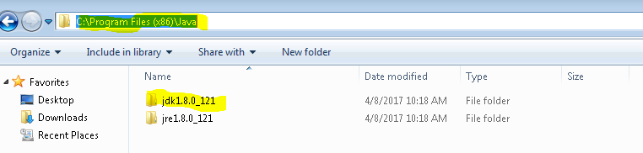

1. Create/Modify “JAVA_HOME” variable under Environment Variables and set path till JDK folder.

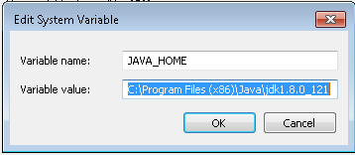

1. Modify “Path” variable under Environment Variables and add path till bin folder of Java.

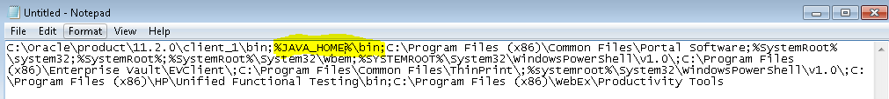

1. Confirm Java version by running java –version command on CMD.

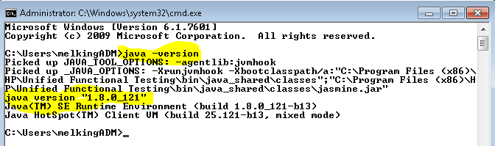

1. Download Eclipse Java IDE 32 Bit version and store it in “C:\Apps” folder.

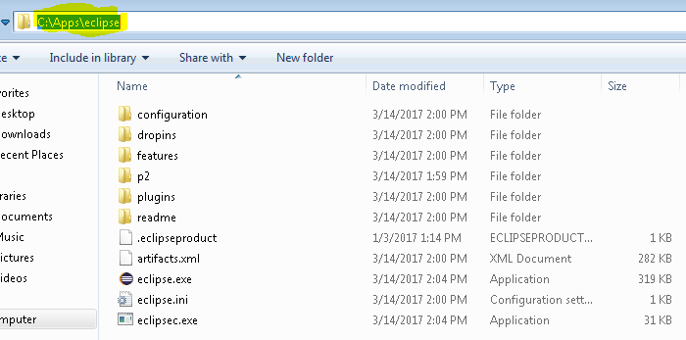

1. Download Apache Maven and extract zip file into “C:\Apps” folder.

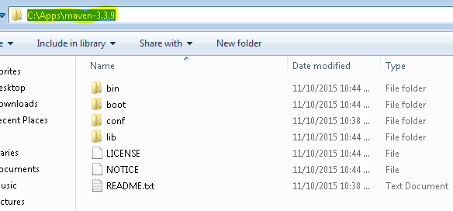

1. Create a new environment variable “M2_HOME” and set path to Maven folder.

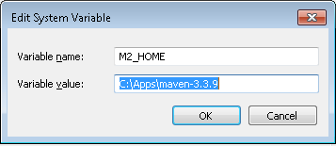

1. Modify “Path” variable to add Maven.

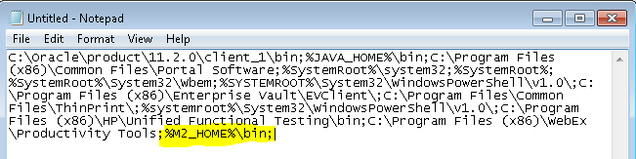

1. Verify Maven setup is complete by running “mvn –v” command in CMD.

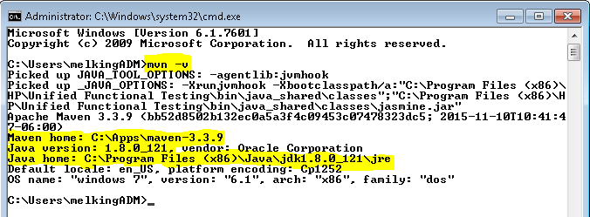

1. From Charter Software Center install latest version of HP ALM.
2. After installation is completed, copy “OTAClient.dll” & “WebClient.dll” files from “C:\ProgramData\HP\ALM-Client\{Latest Version folder}” and paste it into “C:\Windows\SysWOW64” folder.
3. After this copy “com4j-amd64.dll” & “com4j-x86.dll” files from “X:\Automation\Framework\Com4j” folder and paste into “C:\Windows\SysWOW64” folder.
4. Register these 4 dll files by running “regsvr32 {dll filename}” command in CMD on “C:\Windows\SysWOW64” folder.

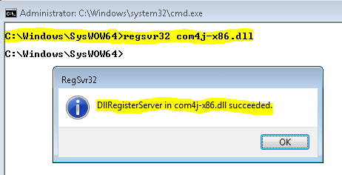

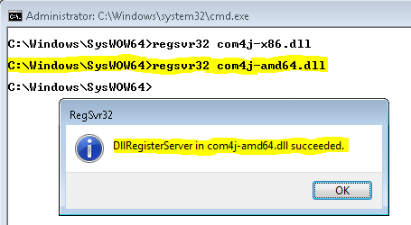

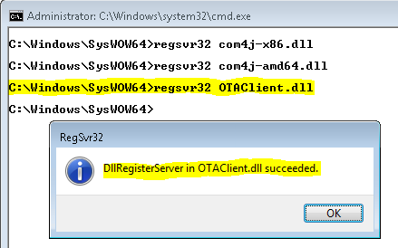

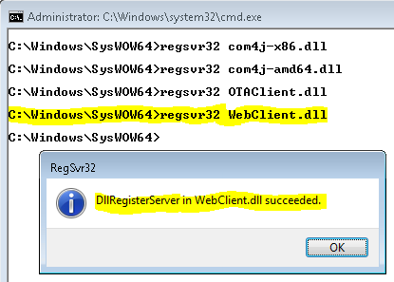

1. Install GIT latest version into “C:\Apps” folder.
2. Setup at least 1 GIT based project in Eclipse like “nextgen/T3/eComm” so as to download all the Maven dependency files into user profile.
3. Now log onto JENKINS server <http://kstlitqavm033.corp.chartercom.com:8080/> from that slave machine using Admin credentials like svc_automation.
4. Click on “Manage Jenkins” menu item from left hand side bar.

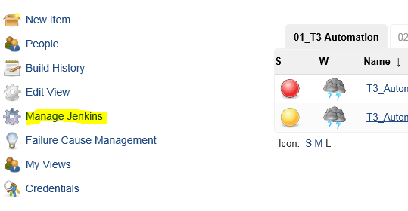

1. From the list of items, click on “Manage Nodes” option.

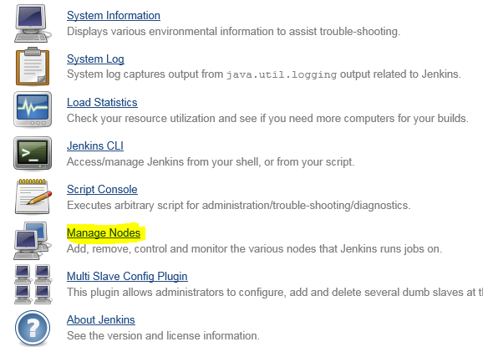

1. Here you will see already configured list of Slave machines to run Jenkins job.
2. From left hand side menu bar, click on “New Node” option.

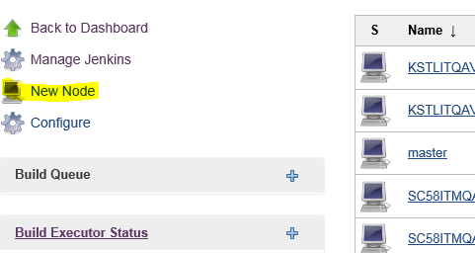

1. Provide value into Node Name field. It should be same as the Computer/Hostname. Run “hostname” command in CMD and copy the value and paste it into above field.

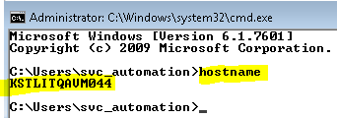

1. Select Copy from Existing Node option and provide any existing Node Name if available. It has text auto-complete feature so just start typing first 2 characters and suggestions will be displayed. Select any value from the displayed list and Click on OK button.

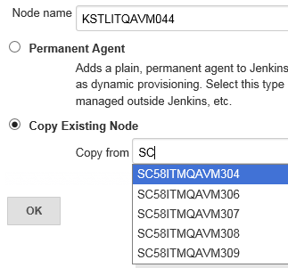

1. Now modify the “Description” and “Labels” field to match with the given name.

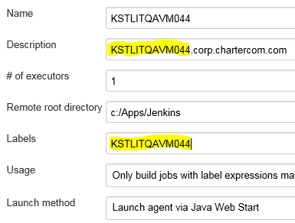

1. Scroll down and validate “Tool Locations” and the variable values. Make necessary changes top point to correct path of GIT or Maven or JDK.

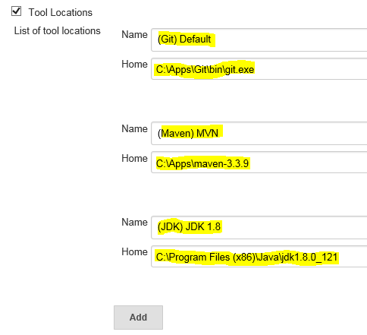

1. After changes, click on Save button.
2. After saving, copy the command given on screen (highlighted in below image) and save it into a .bat file. Name the file as “slave-startup.bat”. (You can give any name to this file but to keep consistency we have used this name)

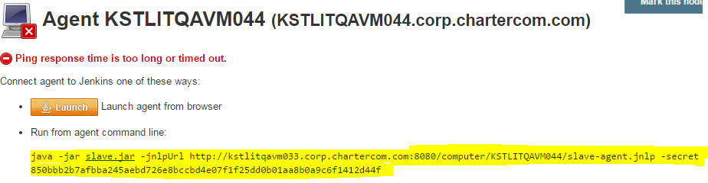

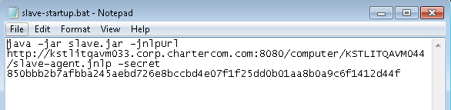

1. Download the slave.jar file from Jenkins and place it onto Desktop by clicking on slave.jar link.

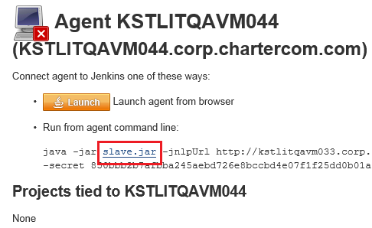

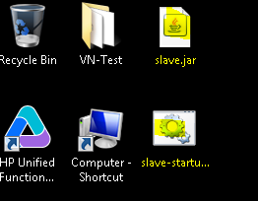

1. Double click on “slave-startup.bat” and let it open CMD prompt. Refresh the Jenkins page or click on Status option from left hand side bar.

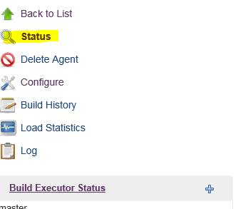

1. You will see that slave is now connected to Jenkins.

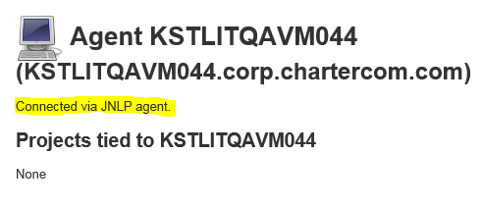

1. Jenkins slave machine setup is completed. To verify connectivity & execution, associate any existing Jenkins job to run on slave machine.
2. Now to keep this machine always connected as a slave to Jenkins, add this “slave-startup.bat” to startup folder so that if computer restarts then it gets automatically connected to Jenkins. For it, create a shortcut for “slave-startup.bat” file and add it into “C:\Users\{UserName} \AppData\Roaming\Microsoft\Windows\Start Menu\Programs\Startup” folder.

